CATCH-UP | TUESDAY 07/12/21
DRAMA | W/C 08/11/21
MFL SPEAKING | JANUARY 2022 (tbc)
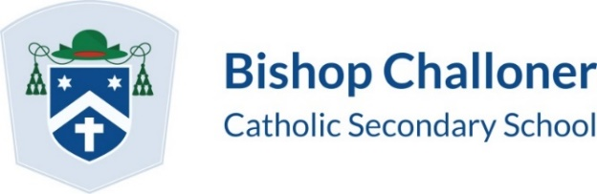

Year 11 Mock Exam Schedule November/December 2021
 | 09:15 – 11:30 |  | 14:00 – 15:35
MONDAY 29/11/21 | RE 1HR 45M |  | FRENCH LISTENING 45M  SPANISH READING 45M
 | 09:15 – 11:30 |  | 14:00 - 15:35
TUESDAY 30/11/21 | ENGLISH 1HR 50M |  | SPANISH LISTENING 45M  FRENCH READING 45M
 | 09:15 – 11:30 |  | 14:00 – 15:35
WEDNESDAY 01/12/21 | GEOGRAPHY 1HR 30M |  | FRENCH WRITING 60M  SPANISH WRITING 60M
 | 09:15 – 11:30 |  | 13:00 – 15:35  EARLY LUNCH REQUIRED (12:35)
THURSDAY 02/12/21 | MUSIC 1HR 15M  FOOD PREP AND NUTRITION 1HR 45M  PE 1HR 15M  DT 2 HRS |  | BIOLOGY 1HR 45M  COMBINED SCIENCES (BIOLOGY) 1HR 15M
 | 09:15 – 11:30 |  | 13:00 – 15:35  EARLY LUNCH REQUIRED (12:35)
FRIDAY 03/12/21 | BTEC H&S 2 HRS  BTEC SPORT 1HR 30M  BTEC ENG 1HR 30M |  | CHEMISTRY 1HR 45M  COMBINED SCIENCES (CHEMISTRY) 1HR 15M
 | 09:15 – 11:30 |  | 13:00 – 15:35  EARLY LUNCH REQUIRED (12:35)
MONDAY 06/12/21 | MATHS H/F CALCULATOR 1HR 30M |  | PHYSICS 1HR 45M  COMBINED SCIENCES (PHYSICS) 1HR 15M
 | 09:15 – 11:30 |  | 13:00 – 15:35  EARLY LUNCH REQUIRED (12:35)
TUESDAY 07/12/21 | HISTORY 2HRS |  | FSMQ 1 HR  MISSED MOCKS - CATCH UP SESSIONS VARIOUS

