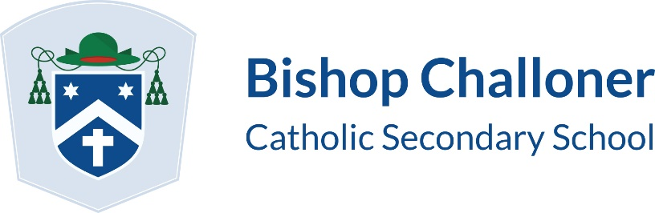

Admission Appeals Timetable for Year 7 in September 2022

All appeals organised by the Independent Appeals Service will follow the timetable below:

National notification date for on-time applicants | Tuesday 1 March 2022
Notification date for late applicants (for applications received after 31 October 2021 and before1 March 2022) | Wednesday 9 March 2022
Deadline date for parents wishing to lodge an appeal (returning completed appeal papers to the County Council) | Thursday 31 March 2022
Year 7 appeal hearings to be held | From 3 May to 10 June 2022, inclusive
Decision letter to be sent | Within seven calendar days of hearing

Please note

- Appeals lodged after 31 March 2022 will be heard during the above dates, if possible. Where it is not achievable to hold an appeal between the above dates, the hearing will be scheduled within 30 school days (excluding any school holidays) of the appeal being lodged. Appeals lodged on or after 10 June 2022 may not be heard until the autumn term.

- Appellants will receive at least 14 calendar days’ notice of the exact date and location of their appeal hearing.

- Following the lodging of an appeal, additional papers may be submitted to the Appeals Service until 14 calendar days before the hearing. Evidence submitted after this date will be considered by the panel but this may lead to an adjournment and significant delays.

