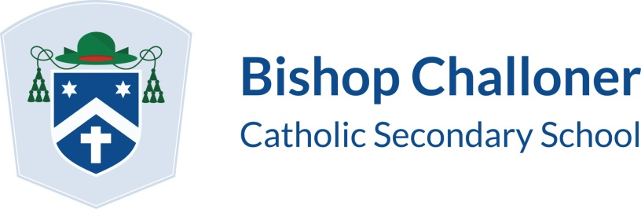

SATURDAY SCHEDULE 2021/2022
Saturday sessions run from 9:00am to 11:45am.
Students must sign up for a Saturday session in advance (via their tutor/Miss MacDonald).
In addition to general revision sessions/study skills sessions, there may also be subject specific sessions on offer. This information will be posted on Showmyhomework at least a week prior to the session.
OCTOBER 2021
09/10/2021
NOVEMBER 2021
20/11/2021
JANUARY 2022
15/01/2022
FEBRUARY 2022
12/02/2022
MARCH 2022
19/03/2022
APRIL 2022
02/04/2022
MAY 2022
14/05/2022

Please note; internal exams are scheduled to commence Monday 29 November and due to finish by Tuesday 7 December 2021.

These dates are provisional. An exam timetable will be issued prior to the October half-term.

Any updates will be communicated to students/parents/carers as a matter of urgency.

