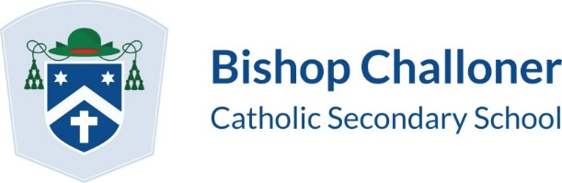

YEAR 11 INTERVENTION 2021-2022
 | MONDAY | TUESDAY | WEDNESDAY | THURSDAY | FRIDAY
LUNCH TIME INTERVENTION | ALM English Language | JBT Music |  | PYK Technology - All invited to complete NEA project  EHM History | PYK Technology - All invited to complete NEA project  HAL – Science  (Triple physics)
AFTER SCHOOL INTERVENTION | Directed time | RAM Food by arrangement  APL Maths targeted revision topics  PYK Technology NEA support sessions | JBT Music by arrangement  RAM Food by arrangement  PYK Technology NEA Support sessions | JBT Music by arrangement  RAM Food by arrangement  PBE English - All invited  OAK English - All invited and linked to AOs - general skill based | JBT Music by arrangement  LBY Science  (Physics/Chemistry)

History Intervention – One History Help https://www.youtube.com/channel/UCQU5628Mo62xMu0-yAHkbkw
Science Intervention – AQA Biology Videos by Miss Taylor https://www.youtube.com/channel/UC6tfU4JIqJoOi-coLaxxvQw
AQA Chemistry Videos by Mrs Roberts https://www.youtube.com/channel/UC8PbAi6OldxoGCp85aHYl6w
AQA Physics https://www.youtube.com/channel/UCoksQRTIfgAQ-WwJSdOtqGQ
Food Intervention – Keighley’s Kitchen https://www.youtube.com/channel/UCFTVa2oPCs7iWCuSTfXPKPw
Geography Intervention – Geography Rocks by Mrs Wingham https://www.youtube.com/channel/UCDmBlMG-Ot69GTLIQBVSk6w
English – GCSE Pod (An Inspector Calls / Romeo and Juliet / Macbeth / Poetry) Mr Bruff

